<https://oracle-base.com/articles/11g/oracle-db-11gr2-rac-installation-on-oel5-using-virtualbox>

<https://oracle-base.com/articles/12c/oracle-db-12cr1-rac-installation-on-oracle-linux-6-using-virtualbox>

<http://wadhahdaouehi.tn/2015/04/creation-of-asm-disks-on-oracle-linux-using-asmlib/>

<http://nobugnointerest.blogspot.com/2014/06/oracle-cai-at-asm.html>

lấy file của cty truy cập mạng cty

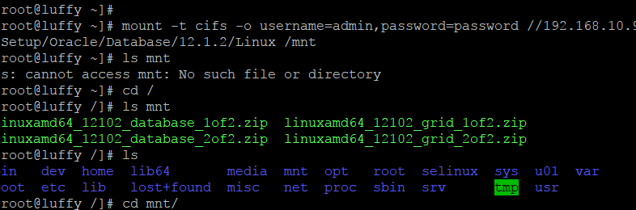

<http://www.happiestminds.com/Insights/role-based-provisioning/>

<https://docs.oracle.com/cd/E27559_01/dev.1112/e27150/callbacks.htm#OMDEV3241>

<http://www.ateam-oracle.com/oim-reset-password-customization-example/>

<http://www.oracle.com/technetwork/documentation/oim1014-097544.html>

<https://docs.oracle.com/cd/E37115_01/install.1112/e27301/install.htm#INOAM74504>

<http://www.oracle.com/technetwork/middleware/ias/downloads/fusion-requirements-100147.html>

<http://docs.oracle.com/html/E18558_01/fusion_requirements.htm#CHDJGECA>

<http://www.oracle.com/technetwork/middleware/ias/downloads/fusion-requirements-100147.html>

<http://www.iamidm.com/2015/09/oim-11g-r2-ps3-installation-steps.html>

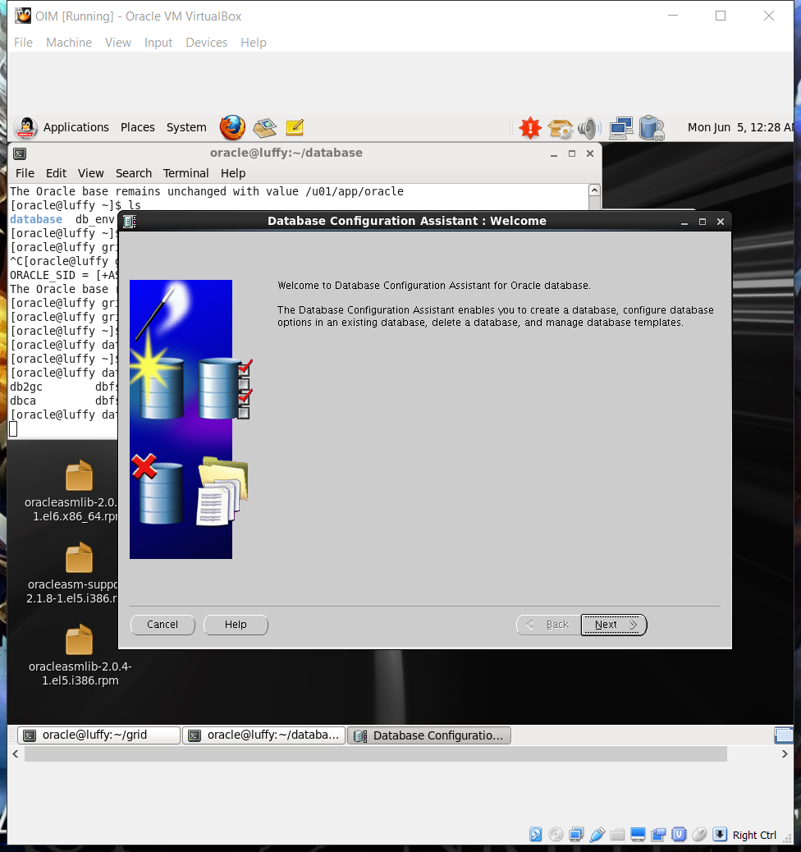

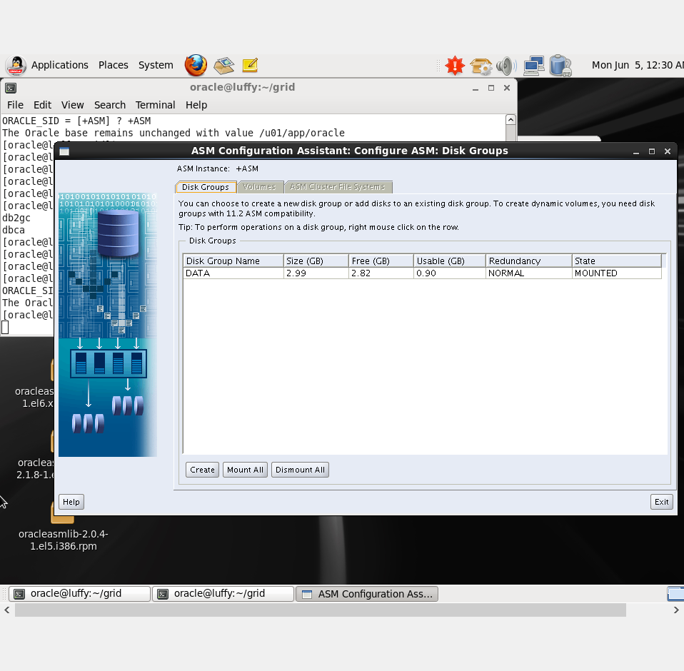

<https://www.youtube.com/watch?v=KgdaSERCyjA>

<https://www.youtube.com/watch?v=Hd4f0T28D4c>

<https://oracle-base.com/articles/11g/oracle-db-11gr2-rac-installation-on-oel5-using-virtualbox>

<https://www.youtube.com/watch?v=q6O6SBP3tdo>

Link ngày 6/5

<http://www.sqlpanda.com/2013/01/use-netca-to-configure-oracle-listener_31.html>

<http://mahameeditpro.blogspot.com/2016/11/creating-oracle-listener-using-netca.html>

<https://dba.stackexchange.com/questions/30561/check-listener-status-other-than-1521>

<https://arvindasdba.blogspot.com/2015/09/information-provided-for-listener-is.html>

<https://docs.oracle.com/cd/E39579_01/html/E39654/gkkho.html>

<http://www.dummies.com/programming/databases/how-to-configure-the-database-listener-with-listener-ora-in-oracle-12c/>

